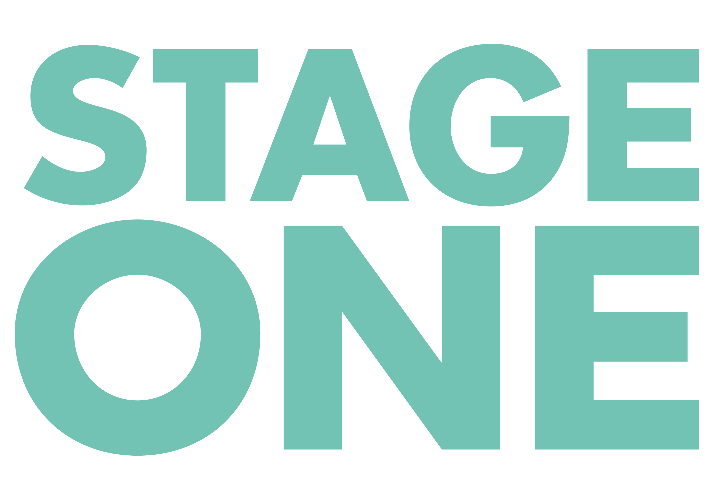
INVESTMENT APPLICATION FORM

If you would like to apply for Small Scale Commercial Investment please ensure that you read our Guidelines before filling out an application. Please complete the following and return to enquiries@stageone.uk.com

Applications are considered upon receipt, throughout the year.

I confirm that the following application is accurate to the best of my knowledge and that the statements below are true;
- The financials listed below are fair and not misleading
- I have attached an up to date CV, recoupment schedule and investment prospectus
- I have attached proof of my Equity Fringe Agreement (if under other union agreements please do also provide proof).
- I have attached details of the venue agreement (you do not need to provide the whole agreement but please include headline information).

Have you attended Stage One’s 3 day producer workshop? Yes/No

Signed ……………………………………………..………… Date………………………….

Name
Email/Tel
Production (Title)
Venue (incl. capacity)
What is the size of investment requested?
Capitalisation
Production Costs
Estimated weekly running costs (excl. royalties)
Will you divide the Stage One investment between any co-producers?

If you are co-producing please list other co-producers and how much they are raising
Length of Run
Author(s)
Star Actor(s)
General Manager
Director
Designer(s)
Choreographer
Synopsis (Max 5 lines)
First rehearsal (Date)
First preview
Date of press night
If touring, please supply full tour dates and deals
The production breaks even (incl. royalties) in how many weeks?
At 75% of box office capacity the production is estimated to recoup in the following number of weeks;
Total weekly fees (including GM, office charges and other producer fees) | £
Pre-production fees (if any) to the producer and/or general manager | £
How many weeks are these received for?
Producer royalty | %
Please list all profit shares (if any) that are paid off the top prior to the Producer(s) and Investor(s) sharing 60/40;

Please list details of the license/rights agreement (incl. subsidiary theatrical income due to the producer under the author's contract & further options available)
Will investors income received from the above be shared with investors?

Thank you for your application – please send to enquiries@stageone.uk.com along with your Invitation to Invest and recoupment schedule. It can take 4 weeks for your application to be reviewed.

