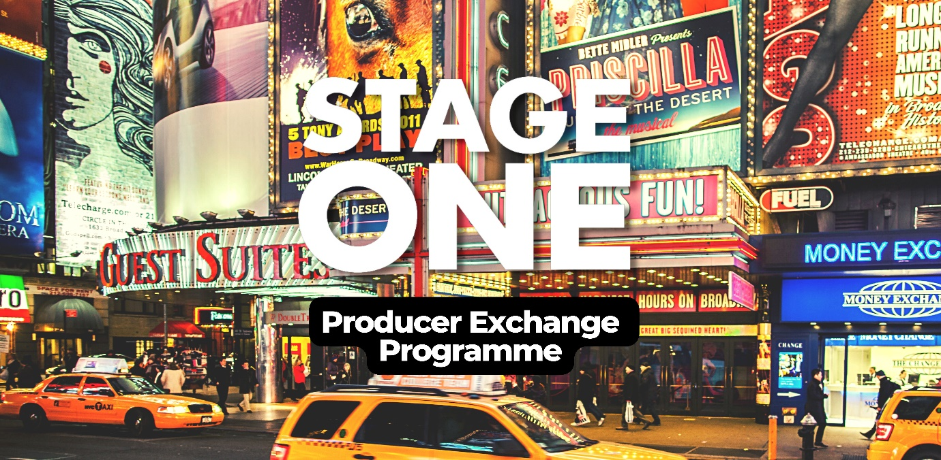

**STAGE ONE & COLUMBIA UNIVERSITY EXCHANGE**

Stage One are pleased to announce our fifth exchange programme with Columbia University. After a successful inaugural programme in 2019-2020, we have integrated the exchange as one of Stage One’s core development programmes. Stage One and Columbia University are thrilled to be working together again and offering this opportunity to a new cohort of producers.

On 12th May 2025, 12 producers taking part in the MFA Theatre Producing Course at Columbia University are coming to the West End for a weeklong intensive series of workshops on how to produce in London and the UK.

In September 2025 Stage One will take 12 producers (who have previously taken part in a Stage One programme) to New York for one week to learn everything about how to produce on Broadway.

**Applications are now open for the 12 UK-based producers wanting to take part in the programme, connect with the New York cohort, and visit the US in September!**

**Deadline**: **Monday 31st March, 12 noon**

***Who is eligible to apply?***

The course is designed for Stage One producers who have a clear ambition to produce on or off Broadway, including taking work to New York that has originated in the UK.

Applicants will need to:

- have attended the Stage One West End workshop (3-day workshop)

- have a clear track record of lead producing mid to large scale theatre in the UK

- be eligible to travel to the USA

With the small number of places and intensity of the course it’s essential that applicants understand the collaborative

nature of the course and are fully committed to attending every session and fully participating.

Successful applicants will need to be able to attend the week-long workshop from **15th – 19th September** in New York, and also be available to meet with the American producers visiting, on the evening of **12th or** **13th May 2025** (final date TBC).

**Grant**

Stage One will offer a grant of **£3,500** to each of the 12 Stage One producers to support the costs of travel, accommodation, and expenses for the exchange. If accepted onto the exchange this will be paid in full up front, and it is your responsibility to make and manage all bookings.

**We understand there are many potential reasons why producers may not be able to or may not feel confident in applying to the New York Exchange programme. If you have any questions about barriers – of any kind – to apply to this programme, we very much welcome you to get in touch for an informal conversation. Get in touch via** [**enquiries@stageone.uk.com**](mailto:enquiries@stageone.uk.com) **or 020 7557 6737.**

*“Stage One is thrilled to be hosting our fifth Producer Exchange in partnership with Columbia University, providing a chance for aspiring commercial theatre producers to build stronger ties with their fellow producers in New York. Creative teams in the US and the UK have a great history of collaboration and we hope this programme continues to inspire these collaborative partnerships and future commercial projects.”*

**-Joseph Smith, Chief Executive, Stage One**

*“The Stage One NYC Exchange has been an incredible experience that has opened up a world of opportunity and potential for my work. The chance to meet and learn first-hand from experienced Broadway/Off-Broadway professionals has been invaluable and I can clearly see a future for my career on Broadway. I can’t wait to put all I've learnt into practice!”*

**-Lauren Townsend, Producer, Mad Friday Productions**

***How will it work?***

Once the producers have been chosen and the grants awarded, it is then up to producers to book their flights, accommodation, and arrange necessary visas/ESTA.

There will be time for you to meet and get to know the other UK Producers. You may find it useful and most cost effective to book accommodation together.

The sessions in New York will start on the Monday morning so producers need to book flights to arrive over the weekend before it begins. The programme will finish on the Friday evening, return flights can be booked for the weekend. The schedule will be available to producers well in advance so shows and meetings can be booked in around the seminars.

Please see an example schedule of the week in New York below.

***Will I need to attend all the sessions in New York and London?***

The Stage One producers are expected to attend all the training & development sessions in September in New York which may include some evenings. We have factored in plenty of opportunities for individuals to see shows and to network.

When the Columbia students are in the UK in March 2025, the Stage One producers are required to attend on the afternoon and evening of 12th or 13th May to meet the US cohort.

***Access, Wellbeing & Safety***

We understand there are many reasons someone may wish to take part in this programme, but may not feel able to, or may not feel confident in doing so. We want to do all we can to ensure that everyone feels safe, comfortable, and excited to undertake their place on this exchange.

After confirming your place on the Exchange, we will ask producers to provide us with an Access Rider to start a conversation around how we can help you get the most out of your experience. Please note we will likely need to share these (with your permission) with the Columbia University team who will be hosting you. Together, we will do all we can to meet your access needs.

At least one member of the Stage One team will be with you in New York, and on hand to answer any questions or concerns you may have. There will also be plenty of time for you to get to know your fellow UK producers before departure. You may find it useful, as well as most cost-effective, to book your accommodation together or close by. If you need any advice on where to stay in New York, you’re welcome to get in touch with Stage One.

If you have any questions about access, wellbeing or safety regarding the New York Exchange, we’re very happy to have an informal conversation. Get in touch via [enquiries@stageone.uk.com](mailto:enquiries@stageone.uk.com) or 020 7557 6737.

This project & the support bursaries for producers are graciously supported by the [John Gore Organization.](https://www.johngore.com/)

John Gore

|  |  |
| --- | --- |
|  | **Monday** |
| 10am | Welcome & Introduction to the week |
| 10.15am | Overview of Theatre Categories/Business Classification; Budgets and Royalties; US Labor Law and Unions; Theatre License Agreements |
| 12.30pm | Lunch |
| 1.30pm | US Fundraising – Front Money, Developmental, LLCs, Co‐Producer  Entitlements and Operating Agreements |
| 4pm | End |
|  | **Tuesday** |
| 10am | US Copyright Law; Author and Creative Team Agreements |
| 12.00pm | Lunch |
| 1.00pm | US Fundraising ‐ Financial and Tax Considerations |
| 2.30pm | Not‐for‐Profit Theatres and Service Organizations |
| 4pm | End |
| 8pm | Show |
|  | **Wednesday** |
| 11am | Introduction to the Broadway League (Labor & Government Relations, Research, etc.) |
| 12.00pm | The Role of the Press Agent; Developing Projects in the USA |
| 1.00pm | End |
| 8pm | Show |
|  | **Thursday** |
| 9:30am | The Shubert Organization; Theatre Owners and Theatre Booking |
| 11am | Ticketing: Ticket Sales, Secondary Ticket Market, Dynamic Pricing, Inventory Management |
| 1.00pm | Lunch |
| 2.00pm | Not‐For‐Profit Co‐Production and Enhancement |
| 4pm | End |
|  | **Friday** |
| 9:30am | Marketing Strategy and Budget |
| 11am | Touring |
| 12.30pm | End of Exchange |